September 28, 2018
Sponsored by: DuraEdge, Sports Turf Specialties INC, Pioneer Athletics
Fall workshop
Burnt Hill Park 148 East Street Hebron, CT 06248
DuraEdge, Greg Federick, Fall season best practices for putting your infield skins to bed for the winter.
Pioneer athletics, Tom Cataldi, Matt Tobin, Latest technology on saving you time and money getting your fields lined with the Tiny Line Marker Mobile robot.
Sports Turf Specialties, Dennis Brolin, Ben Leach, High wear areas. Best maintenance practices for pre, during and post season for best results.
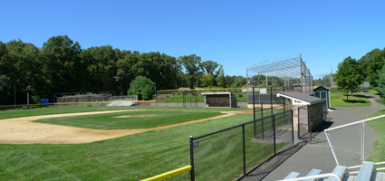

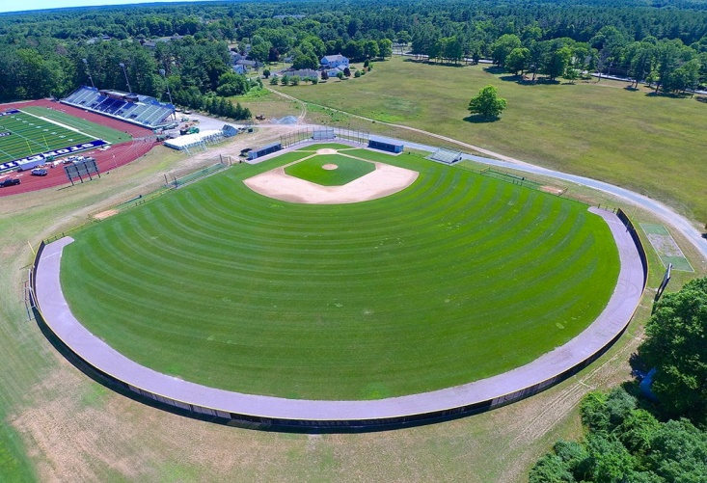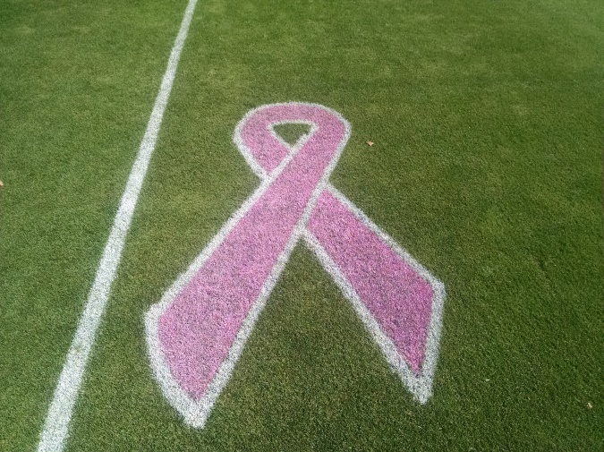
Contact: Matt Tobin, Pioneer Athletics, 207-229-4801, mtobin@pioneerathletics.com
Contact: New England Park Association, Colin Drury, 413-221-1485, colin@myrec.com

Registration
Pesticide credits pending
All Proceeds to go to :
xxxxxxxxxxx
8:00 am-1pm
Hebron Parks and Rec, Rich Calarco
Rich will discuss the history of Burnt Hill Park. Rich will talk about the maintenance program at the park and what has worked best for them.
Sports Turf Specialties, INC, Dennis Brolin
Denis will discuss proper techniques and best maintenance practices for pre, during and post season for best results on high wear areas. Fertilizing, overseeding, weed management practices for optimal outcomes.
DuraEdge, Greg Frederick
Greg will educate on best practice for fall maintenance on skinned areas. How to get your mound and batters boxes prepped and ready for spring sports. Proper dragging, watering, top dressing, lip management techniques will be discussed.
Pioneer Athletics, Matt Tobin, Tom Cataldi
You will learn about cutting edge technology on Tiny Line Marker Robotic paint machine. Learn how Satellite and RTK networks along with a robot can save you time and money when painting your fields. Demonstrations and a chance to witness fist hand the next generation of helping Sports Turf Managers get fields painted faster and more accurately.

Name(s)_______________________________________________________________
Address_______________________________________________________________
Phone_________________________________________________________________
Email__________________________________________________________________
Total names x $10.00______________(includes all sessions and Lunch)
Check to be mailed to
NEPA
Matt Tobin
5 Chelsea Circle
Saco ME 04072

